The History of Mothers Day

Mother's Day, or Mothering Sunday in the UK and Ireland, is a day to show love, gratitude and appreciation to all wonderful mums everywhere, through acts of kindness and the giving of Mothers Day gifts and flowers. Mothering Sunday and Mother's Day both have different origins; although they represent the same meaning, they originated very differently. We all celebrate the day but very few people actually know its origin. The original meaning of Mothering Sunday and Mother's Day has been somewhat lost but it's still a day to solely appreciate mum.
Mother's Day celebrations date back as far as the ancient Greeks where they would celebrate Rhea, the Mother of the Gods and Goddesses, every spring with festivals of worship. The Romans also celebrated a mother Goddess, Cybele, every March as far back as 250BC.
Mothering Sunday has been celebrated on the fourth Sunday in Lent, in the UK and Ireland, since the 16th century. The date varies in other parts of the world. Many countries follow the US and celebrate Mother's Day on the second Sunday in May, whilst other countries enjoy the day on March 8th which is International Women's Day.

History of Mothering Sunday
Like many traditions and festivities, Mothering Sunday began with a religious purpose. Held on the fourth Sunday in Lent, exactly three weeks before Easter Sunday, it was a originally a day to honour and give thanks to the Virgin Mary, also known as Mother Mary. Such celebrations required people to visit their 'mother' church - the main church or cathedral in a family's area. The spread of Christianity throughout Europe in the 16th century increased the celebrations and firmly put Mothering Sunday on the calendar. It was believed to be essential for people to return to their home 'mother' church to make it a true family honoured occasion. The gatherings reunited families and gave children who worked as domestic servants, or as apprentices away from home (from as early as ten years old), the opportunity to have the day off to join their family and see their mother.
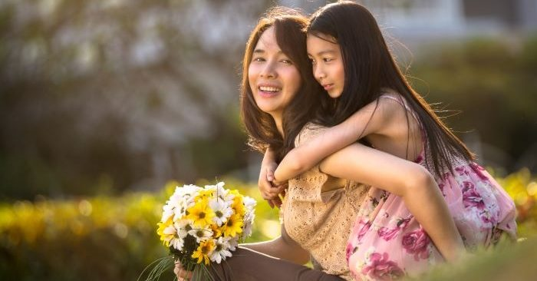
Throughout the year in England and Ireland people would regularly and devoutly visit their nearest chapel, their 'daughter' church, whereas on Mothering Sunday, as well as baptisms, people would visit their 'mother' church loaded with offerings of thanks. Such celebrations were similar to, and most likely adopted, the Roman ceremonies of the Mother Goddess. The religious day increased its scope from thanking Mother Mary to a 'mother' church celebration and finally opened up as an occasion to thank and appreciate all mothers; thus creating Mothering Sunday.
Whilst the day had a firm following for many centuries since the 16th century, by 1935 it started to decrease in popularity and was celebrated less and less in Europe, until WWII. The Americans and Canadians celebrated Mother's Day during the war, feeling a crucial need to give thanks to their mothers whilst away at war. The Brits and other Europeans followed their comrades and they too gave thanks to their mothers; since then it earns pride of place on the UK calendar.

Mothers Day Origins
The US celebrates Mother's Day on the second Sunday in May. The holiday was formed much later than Mothering Sunday, and was created in 1908 by a lady named Anna Jarvis from Grafton, West Virginia, in honor of her late mother. Jarvis pushed hard for a holiday to celebrate all mothers after the death of her own, and after lots of hard work, determination and promotion President Woodrow Wilson finally made it an official holiday for the US in 1914.
However, as the holiday grew more and more established it became more and more commercialized much to the disgrace of Jarvis, who named it "Hallmark Holiday". Jarvis went on to oppose the day and regret what the day had turned into, and she died in 1948 very unhappy with what Mother's Day had become. Nonetheless, in the US Mother's Day still remains a popular holiday making it one of the biggest days for sales of flowers and cards.

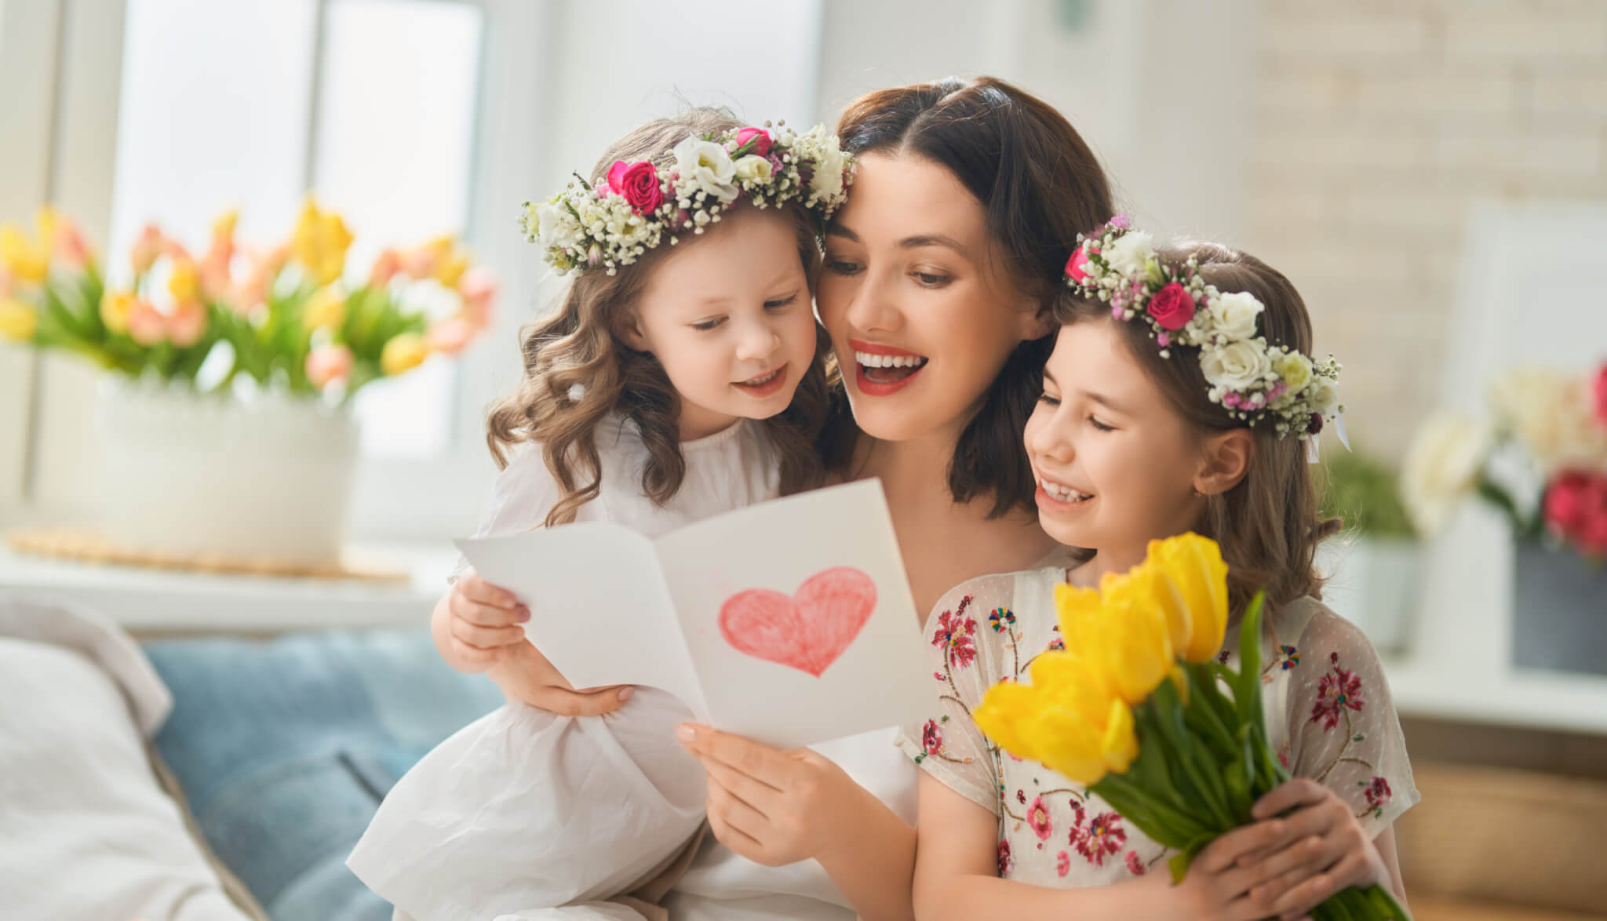

Ann Reeves Jarvis and Julia Ward Howe
The origins of Mother’s Day as celebrated in the United States date back to the 19th century. In the years before the Civil War, Ann Reeves Jarvis of West Virginia helped start “Mothers’ Day Work Clubs" to teach local women how to properly care for their children.
These clubs later became a unifying force in a region of the country still divided over the Civil War. In 1868 Jarvis organized “Mothers’ Friendship Day,” at which mothers gathered with former Union and Confederate soldiers to promote reconciliation.
Another precursor to Mother’s Day came from the abolitionist and suffragette Julia Ward Howe. In 1870 Howe wrote the “Mother’s Day Proclamation,” a call to action that asked mothers to unite in promoting world peace. In 1873 Howe campaigned for a “Mother’s Peace Day” to be celebrated every June 2.
Other early Mother’s Day pioneers include Juliet Calhoun Blakely, a temperance activist who inspired a local Mother’s Day in Albion, Michigan, in the 1870s. The duo of Mary Towles Sasseen and Frank Hering, meanwhile, both worked to organize a Mothers’ Day in the late 19th and early 20th centuries. Some have even called Hering “the father of Mothers’ Day.”

Anna Jarvis Turns Mother's Day Into a National Holiday
The official Mother’s Day holiday arose in the 1900s as a result of the efforts of Anna Jarvis, daughter of Ann Reeves Jarvis. Following her mother’s 1905 death, Anna Jarvis conceived of Mother’s Day as a way of honoring the sacrifices mothers made for their children.
After gaining financial backing from a Philadelphia department store owner named John Wanamaker, in May 1908 she organized the first official Mother’s Day celebration at a Methodist church in Grafton, West Virginia. That same day also saw thousands of people attend a Mother’s Day event at one of Wanamaker’s retail stores in Philadelphia.
Following the success of her first Mother’s Day, Jarvis—who remained unmarried and childless her whole life—resolved to see her holiday added to the national calendar. Arguing that American holidays were biased toward male achievements, she started a massive letter writing campaign to newspapers and prominent politicians urging the adoption of a special day honoring motherhood.
By 1912 many states, towns and churches had adopted Mother’s Day as an annual holiday, and Jarvis had established the Mother’s Day International Association to help promote her cause. Her persistence paid off in 1914 when President Woodrow Wilson signed a measure officially establishing the second Sunday in May as Mother’s Day.

Mothers Day Gift Giving
As with any national holiday, Mother's Day involves the giving of gifts and cards to show Mum how much she's valued and appreciated. Traditionally Mother's Day gifts included flowers and a Simnel cake. The flowers were picked by the workers on the way home from work for a day with their mum; they'd pick wild flowers from the country lanes. It is still a tradition today to spoil mum with a stunning colourful bouquet of flowers, as well as more modern gifts such as perfume, clothes or jewellery.

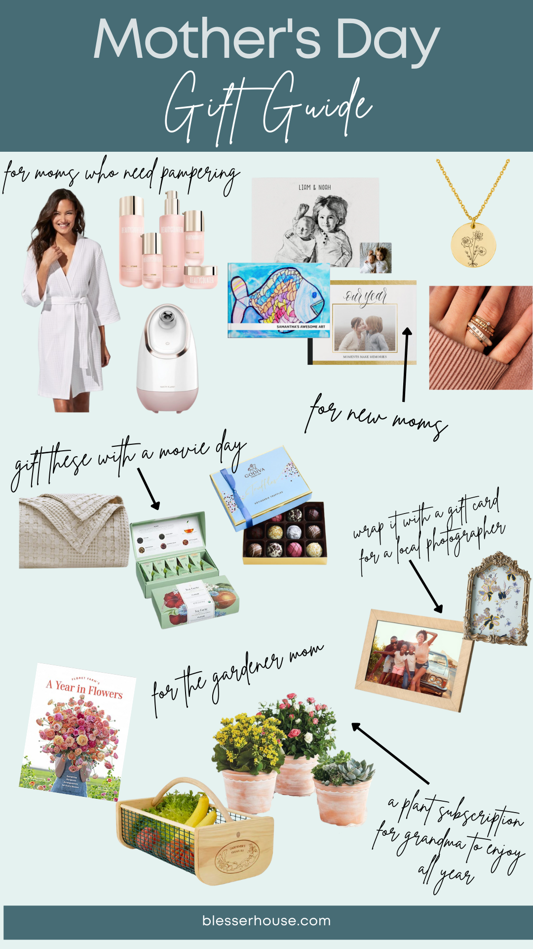

Food on Mothers Day
As with any national holiday, food always seems to take centre stage; Christmas dinner, Easter eggs, Valentine's feast and Mother's Day Sunday roast dinner. We love our food and the tradition it brings!
Mothering Sunday was once also known as 'Refreshment Sunday' it was the mid-lent Sunday where fasting could be 'eased' for the day and people could enjoy a delicious meal together as a family. It was an opportunity to temporarily indulge in some special rich food for the day breaking up the hard slog of lent. Traditionally, after church, families would tuck into a Sunday dinner of either roast lamb or veal and mother would be made Queen of the feast. Similar to today, Mothering Sunday was all about spoiling mum and making her feel happy and appreciated.
Also once known as 'Simnel Sunday', families would gather with freshly baked delicious Simnel cakes. Simnel cakes are made of two rich fruity layers that are boiled in water and then baked, before having almond paste spread on top and in the middle of the layers. Traditionally the cake would have been decorated with 11 balls of marzipan to represent the 11 disciples (not including Judas), whilst sugar violets were also a popular decoration for the cake. Such a treat midway through lent was greatly looked forward to.
Traditionally, it's believed that bread was also freshly baked for mothers on Mothering Sunday. Children would awake early and get the bread in the oven so mums would wake to the beautiful aroma of fresh bread. Nowadays mum's are either taken out for a special dinner or a home cooked Sunday roast dinner is enjoyed by the whole family - mums might even be cooking it themselves!
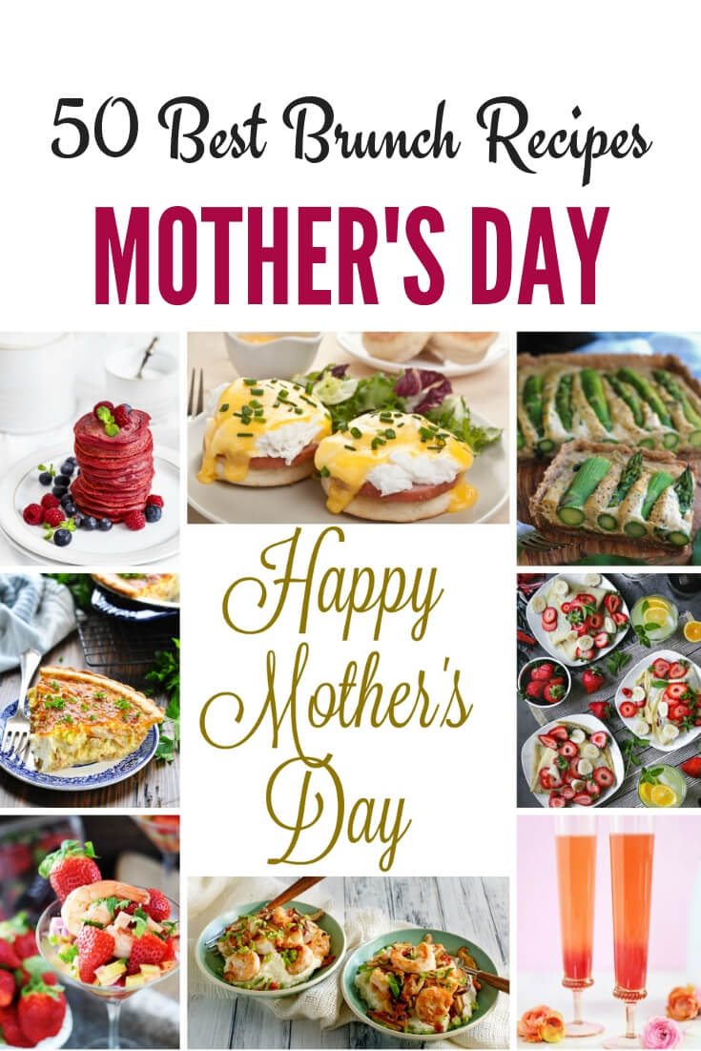

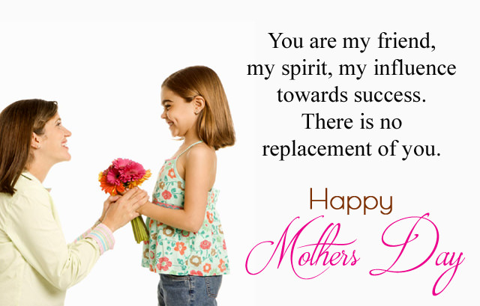

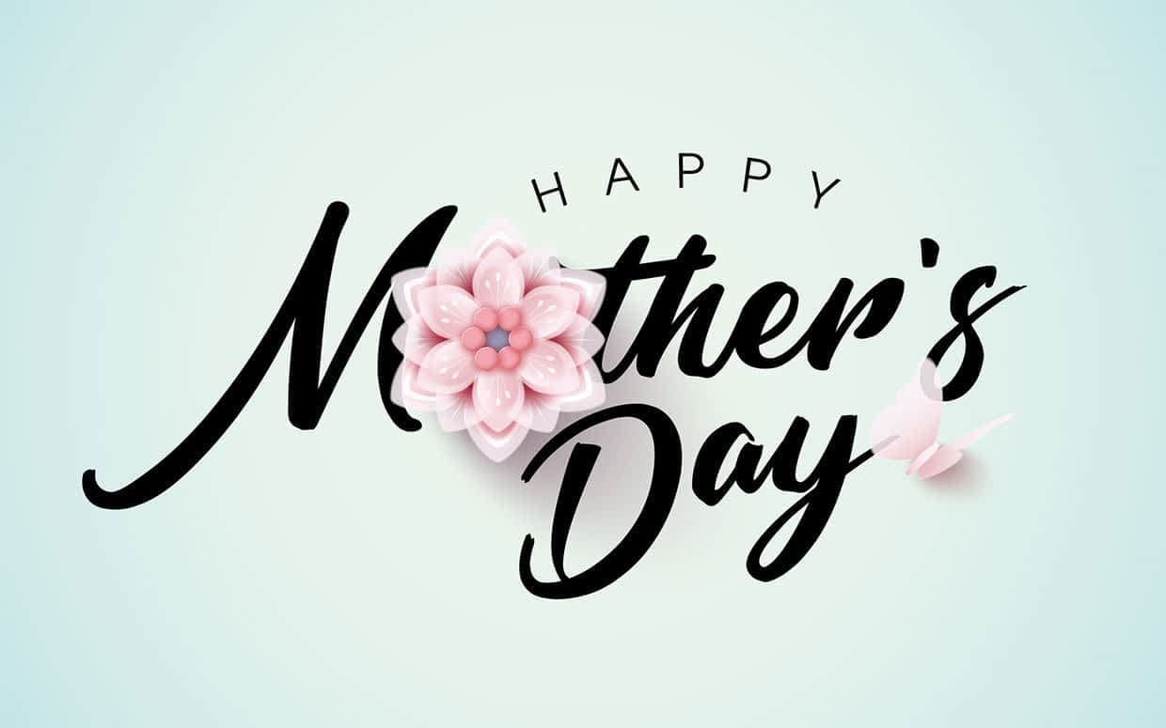
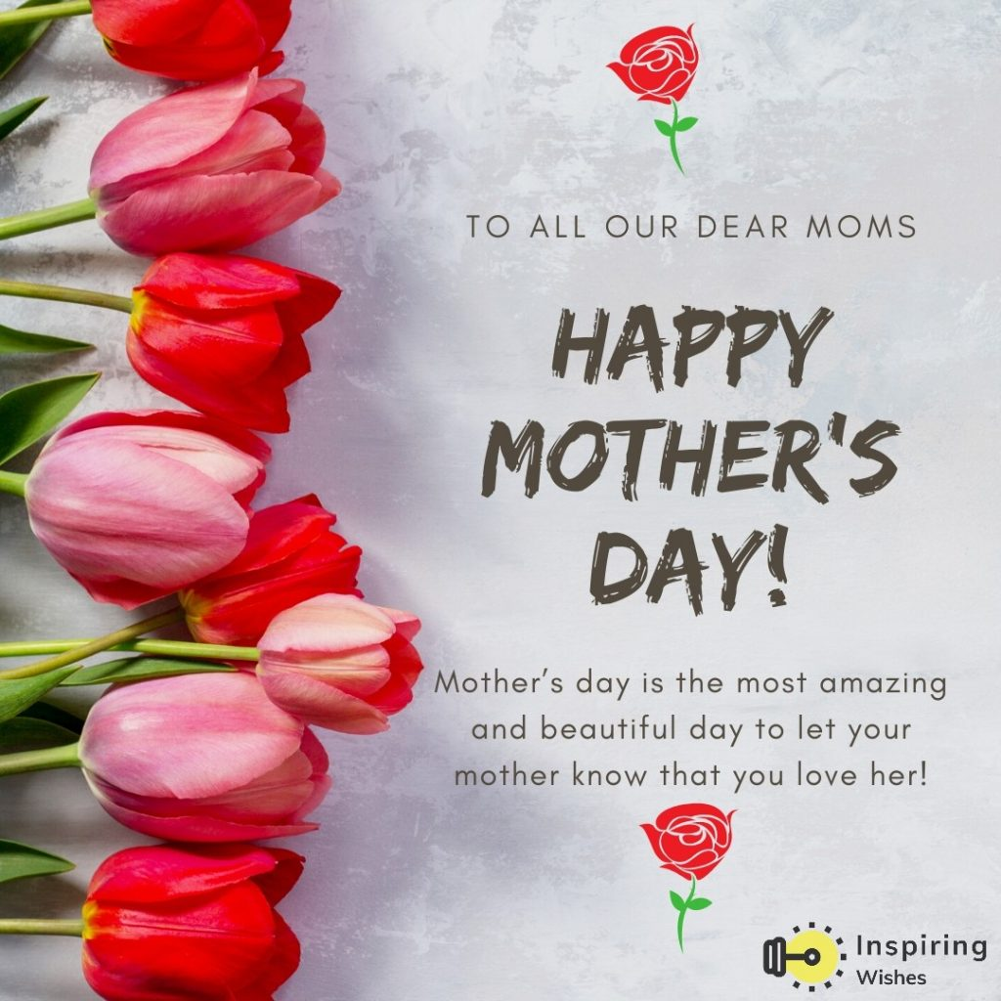

“Mua Vu Lan” – Mother’s Day In Vietnam Dayin Vietna

Westerners have Mothers’ Day to be proud of, the Vietnamese treasure their seventh full moon of lunar calendar (“Mua Vu Lan“) as a time to express filial piety to their parents, especially their gratefulness and appreciation to their mother.
Annually, Vietnamese children honor their parents and try to help the lost souls of their ancestors find their way back to earth.
“Mua Vu Lan” is closely connected to the Asian tradition of ancestor worship and filial piety. It is also known as the Buddhist holiday, a traditional event in praise of motherly love held solemnly once a year in Vietnam.

What Does the Legend Really Mean?
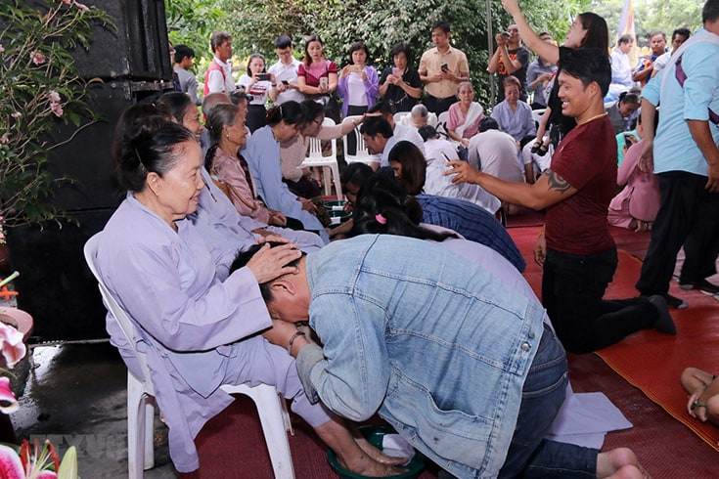

The legend behind the festival dates back to the earliest of Buddhism. One day when he was meditating, Muc Kien Lien, one of the Buddha’s ten principle disciples, saw his late mother suffering the tortures of hell, condemned because of the evil deeds she had committed during her life.
He saw that his mother was starving, but she had nothing to eat but fire. Muc Kien Lien summoned all his spiritual powers to bring her a bowl of rice but the food was burnt to ash before she could bring it to her mouth.
When he arrived back in the physical world, he asked for the Buddha’s guidance to help his mother and fulfill his duty as a pious son. The Buddha advised him to collect a gathering of monks and devotees and get them to pray together on this day (which this year falls on August 15 in the Western calendar).
The combined prayers proved to be so powerful that they achieved the release not only of Muc Kien Lien’s mother, but also for countless other souls. Ever since, on the festival of Vu Lan Wandering Soul’s Day- the gates of hell are believed to be thrown open to give the tormented souls 24 hour holiday.

A Solemn Sharing
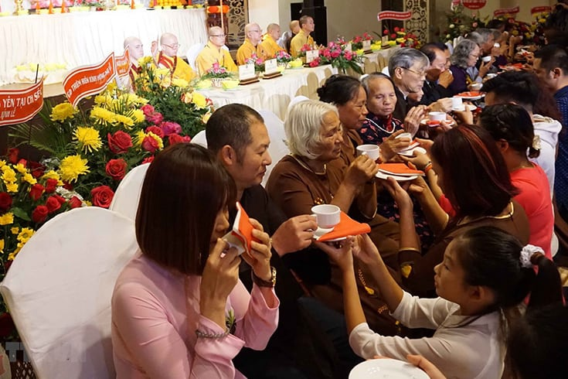

“Mua Vu Lan” is believed to be the spirit month in Vietnamese culture as a way of honoring the dead. On this day, souls are believed to return to their former homes.
From this assembly, many Buddhist countries developed the custom of offering food, clothing and other items to hungry spirits in the month when the realms of Heaven, Hell and the living are open.
The object of this ceremony is to feed the hungry ghosts and to pray for their salvation. This ceremony is a way for people to meet their compassionate filial duty. During the ceremony, offerings are made to rescue up to seven generations of ancestors from whatever misery they might be suffering. During the month, every family can choose a day to present a feast and burn joss paper and incense in front of the house to invite the spirits to eat.
The most distinguished feature of the ceremony is the “offering snatching.” After the incense burns down, the neighborhood children are allowed to grab the food. No one will stop them as it is believed the spirits may be angered if they do so. The ceremony is also a great chance for people to express their gratitude to their parents.
One more tradition of this day is for people – Buddhists and non-Buddhists alike – who wish to express their gratefulness and appreciation towards their mothers, to go to a pagoda, often wearing a rose. Thousands of people flock to pagodas wearing red roses if their parents are alive or white roses if their parents have passed away. The rose has been a symbol of love and sharing among parents and their children regardless of social background.

